

Character Creation Guide

v2024-06-16

# Title Gradient 6Character Creation

This guide explains how to quickly create a QuestGuard Character and fill your Character Sheet. It will also gloss over some game rules to bring you up to speed with the system.

## Character Sheet

To store info about your Character, you need a Character Sheet - a sheet of paper with fields to complete, either digitally or on paper.

You can download a Character Sheet from the website at <https://questguardrpg.com> under Downloads.

For the digital version, get **Character Sheet (PDF)**. Using a PDF software, you can edit the form fields (don’t forget to save it).

For the print & pen version, get **Character Sheet (PNG)**.

## What makes a Character

Every Character is a combination of a Race and a Class.

You can find all official Races and Classes on the website under Databases.

Every combination is viable - you can’t make a bad choice, so choose what you think sounds fun to start with.

Once you’ve decided, complete the Race and Class field on the Character Sheet (e.g. Dwarf Cleric) and give it a good name.

## Main Stats

There are 5 main stats in QuestGuard: Might, Dexterity, Intelligence, Sense and Charisma.

To complete them, put the following numbers, in any order, each into one of the 5 Main Stats:

-1 0 1 2 3

However, note that your Race might impose some small restrictions on your Main Stats.

For example, here are the restrictions for a Dwarf:

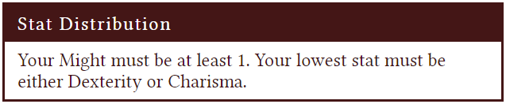

*For example, 3 Might, -1 Dexterity, 1 Intelligence, 2 Sense, 0 Charisma is a valid way to fill in Stats.*

*0 Might, 1 Dexterity, -1 Intelligence, 2 Sense, 3 Charisma is not valid for the Dwarf.*

# Title Gradient 6Race Fill-Ins

First, go through each of a Race’s numbers and fill them in. Most should be self-explanatory.

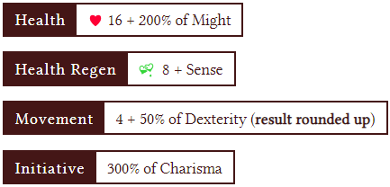

Fill in your Health (the heart), Health Regen (the small field on the bottom-right of the heart), the Movement Speed (the circle) and the Initiative to be exactly how the Race tells you.

For example, if your **Might** is **3**, then 200% of your **Might** is 6. As such, 16 + 200% of your **Might** is

16 + 200% of 3 = **16** + **6** = **22**.

**Health Regen** represents how much Health you heal after you finish a combat.

If your **Sense** is **2**, then your **Health Regen** is

**8** + **2** = **10**.



Every turn, you can move a number of meters equal to your **Movement Speed**.

If your **Dexterity** is **1**, then your **Movement Speed** is 4 + 50% of 1 = **4** + **0.5** = **4.5**.

Rounded up, your final Movement = **5**.

:

* *-1 and 0 Dexterity = 4 Movement*
* *1 and 2 Dexterity = 5 Movement*
* *3 and 4 Dexterity = 6 Movement*

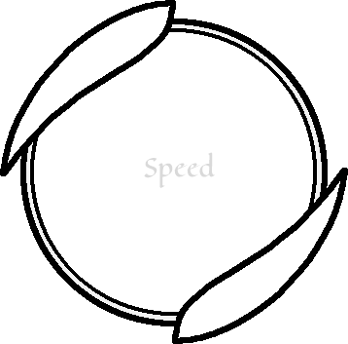

On the start of combat, you roll a d12 die and add your **Initiative**. Characters take their turn in the order of their rolled **Initiative** (highest goes first).

If your **Charisma** is **-1**, then your **Initiative** is **-3**.



Your **Intelligence** will be explained later.

## Languages

Each Race will let you speak a number of languages. Follow the guideline of the Language box, and put them in the Languages field on the Character Sheet.

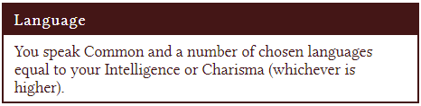

There are many language options, and you should consult with your Quest Master to see which could be useful. Languages vary from world to world, but here is a comprehensive list of *standard* ones:

* *Common*
* *Dwarvish*
* *Elvish*
* *Orcish*
* *Goblan*
* *Sylvan (spoken by fae creatures)*
* *Gian*
* *Undran (spoken in underground societies)*
* *Infernal (spoken by demons)*
* *Celestial (spoken by angels)*
* *Ancian (old Common)*
* *Abyssal (non-spoken eldritch language)*
* *Doublespeak*
* *Whistletone (camouflage whistles, claps, etc)*
* *Draconic (shouts and breath-work)*
* *Sign language*

## Race Abilities

Each Race will give you a set of Abilities. You can note these down on the Character Sheet under Ability Notes.

## Keeping track of Abilities

You might not have enough space on your Character Sheet to track all your Abilities.

However, there exist several ways to keep track of your Abilities!

The easiest way is using the **online Ability Sheet Maker**.

Go to **Database**, under **Other**, and open up the **Ability Sheet Maker**. Then simply select each of your Abilities and hit Add.

You can save the complete URL (the one in the top of the page) in a text file on your computer to save your Ability Sheet, then open the URL again in the browser to preview your Abilities. The URL updates automatically when you add or remove Abilities.

As another alternative, MS Word, create a blank document, and click on the small document icon on the bottom-right of an Ability to copy it to your clipboard. Then simply right-click in Word and hit Paste (*Ctrl + V*).

Save the new image to have your Abilities ready!

## Race Ability Choice

Finally, each Race gives you one option Ability to choose from. Simply choose one of those and add it to your Character Sheet or Ability Sheet.

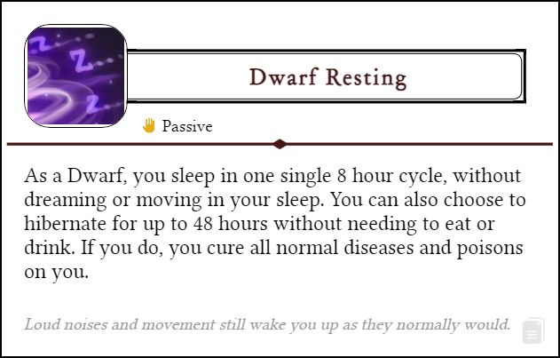

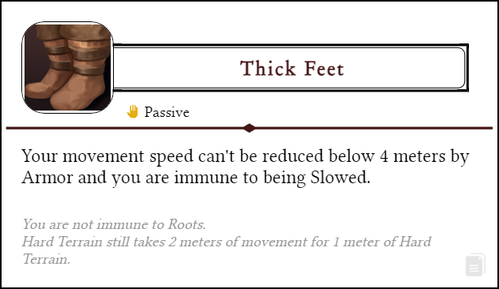

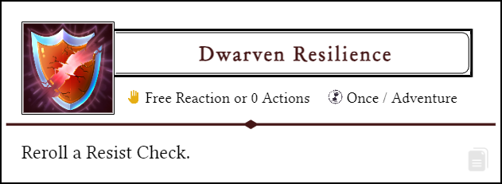

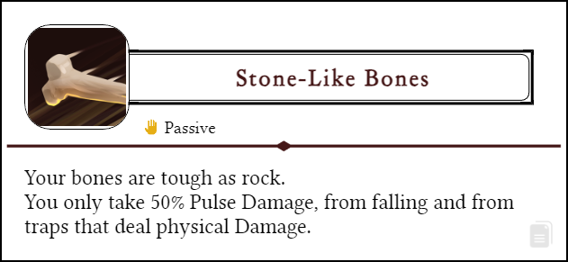

# Title Gradient 6Class Fill-Ins

On your Class’s page, go through each box and add them to your Character Sheet, one by one.

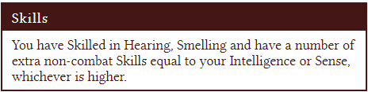

Each Character will have non-combat Skills they can **add themselves to a d12 Check if appropriate**. If you have a Skill, you add your Level to the roll.

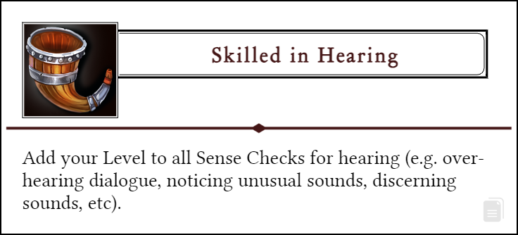

The Quest Master might call for a Sense Check, and, if you are Skilled in Sight, you can say “I am Skilled in Hearing, can I add my Level to the roll?”, to which the Quest Master might say yes or no, depending on the situation.

For example, let’s assume you are Level 4, have 2 Sense and are Skilled in Hearing. You roll 1d12 and add +2 and +4 to the result.

If a non-combat Skill isn’t on the list, feel free to invent your own.

# Title Gradient 6Starting Abilities

Each Class gives you access to certain starting Abilities.

These should be self-explanatory - you get them all!

Put these on your Ability Sheet (on the Ability Sheet Maker online, or on your Word document).

# Title Gradient 6Mana & Spellcasting

## Mana

Mana is the resource used by most characters to cast more powerful Abilities.



You have a number of Mana Points you can use on Abilities.

If you have 5 Mana Points and an Ability requires 2 Mana, you spend 2 Mana and use the Ability. Then, you are left with 3 Mana.

Usually, Mana regenerates in the downtime between *adventures (e.g. between sessions, between dungeons, etc)*.

On your Character Sheet, tick a number of orbs equal to your Mana. You can track your Mana Points on paper with a pencil, a die, or covering an orb with something.



## Known Basic Abilities

Your Character can *know* a number of Abilities from the Basic Ability Lists.

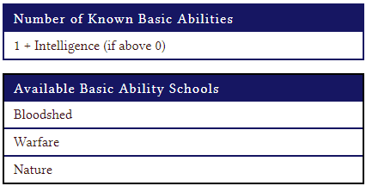

So, go to **Database** and **Basic Ability Lists**, and select that many Abilities as it says in the **Known Abilities (from Basic Ability Lists)** box, from the Ability Lists named above.

You are free to put these on your Ability Sheet (on the Ability Sheet Maker online, or on your chosen drawing app).

Don’t worry about making bad choices - you can change these choices between *Adventures*.

*Note: many Abilities require you to be a certain Level!*

## For example…

For example, if I have 1 Intelligence, as a Cleric, I can know a total of 3 Basic Abilities, from the Mysticism and Divine Lists.

I choose Guidance from Mysticism, and Mending and Solace Wave from Divine.

# Title Gradient 6Equipment & Gold

You begin with 800 gold, which you can spend right now to get equipment for your Character.

## Armor

Your Character (probably) needs armor. Look through the Armors page (under Database, Items).

Choose one that suits your Character (and that you can afford).

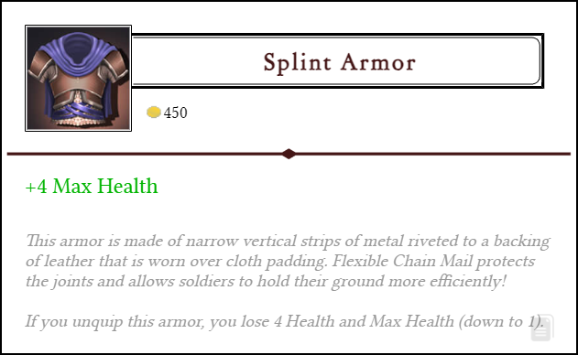

If it gives you any Stats, add them to your Character Sheet.

## Weapons

Look through the Weapons page (under Database, Items). If your Character needs a weapon, choose one (or more) that suits you (if you can afford it).

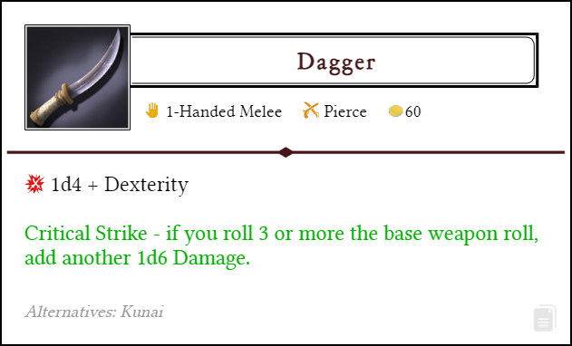

You can write your weapon’s effect in any of the **Weapons, Attacks and Other Quick Combat Notes** boxes.

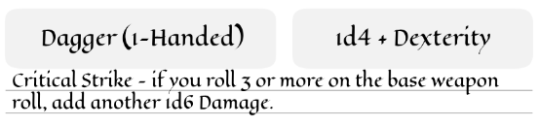

## Runes

You can lightly alter your weapon with Runes, and change the way your weapon behaves.

There are 4 runes available to buy at character creation.

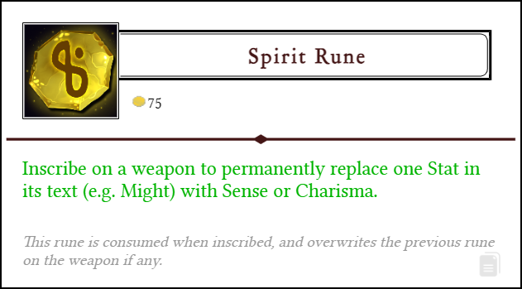

## Other Items

From your remaining Gold, feel free to buy anything on the Prices page (under Database, Items).

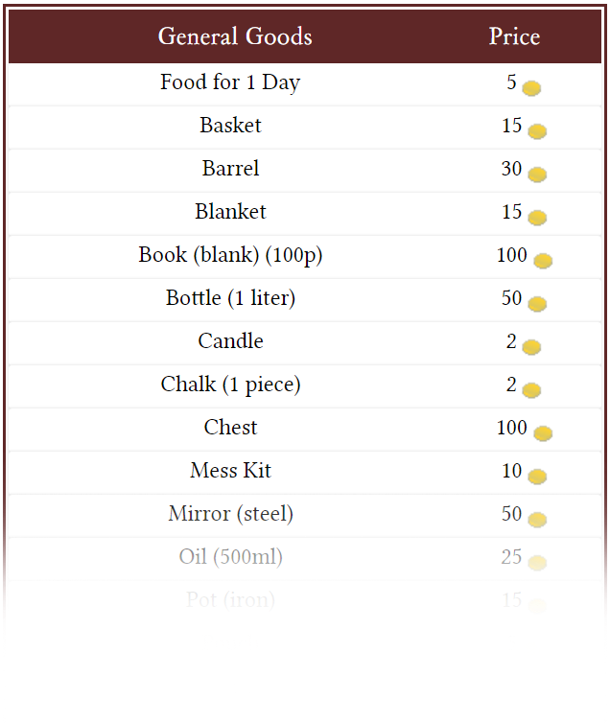

# Title Gradient 6Leveling Up

Whenever you Level Up, your Class will tell you exactly what you get.

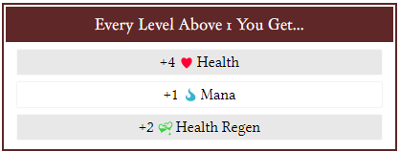

You will also unlock more powerful Basic Abilities (e.g from the. Mysticism or Divine lists).

Other than these, you also get…



## Specialization (Level 2)

At Level 2, you pick your Class’s Specialization. Each Class can pick between (usually) 3 Specializations. Your Specialization simply gives you some extra Abilities that shape how you play and fight.

## Talents (Level 3+)

At Level 3, and Level afterwards, you pick a Class Talent, which is one powerful Ability, usually from 3 or more options.

You can change your chosen Class Talents (Level 3, 5, 7 and 9 Talents) between *Adventures*, so don’t worry about making a bad choice. Try them all out!

Feats (Optional)

There exist an extra set of Abilities called Feats, which you can find on the **Feats** page (under **Database**, **Abilities**).

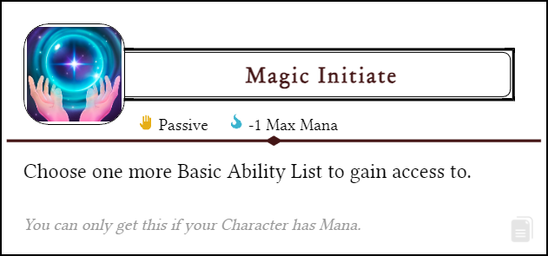

You can get any number of Feats, but each Feat has a cost and is permanent. Choose wisely!

# Done! What’s next?

Join our Discord community and show us your character! Then feel free to join one of the games running on our server - new players are always welcome!

Join at <https://discord.gg/27aqSEDyE3>